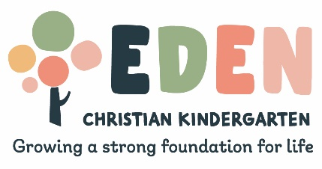
What to bring to Kindy?
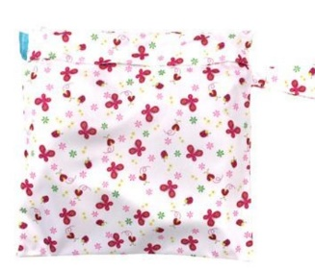
Wet bag
Named change of clothes
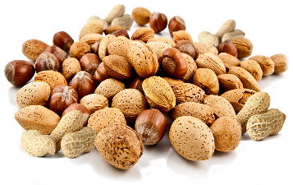
Morning, lunch, and afternoon tea (no nut products or food that needs heating)
This Photo by Unknown Author is licensed under CC BY-NC
Named lunch box and drink bottle.
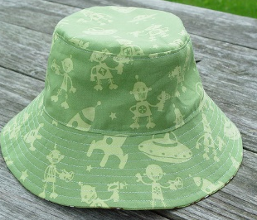
Named sun hat – bucket hat preferred.
Nappies (if required)
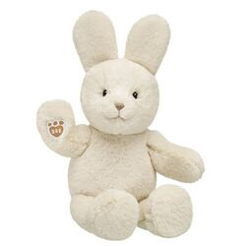
Any special bedtime cuddlees
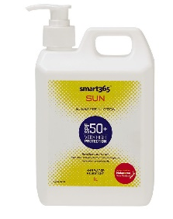
If your child requires special sunblock, please bring named.
Kindy sunblock is smart365.
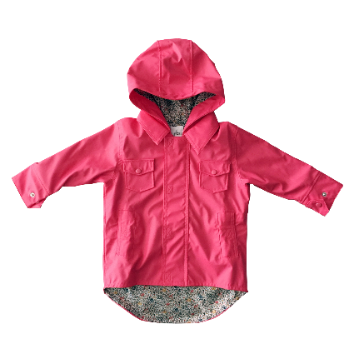
SunSmart clothing is recommended for warmer months and jackets and woollen hats for cooler months.

